# EMPLOYEE DATABASE

**Week5**

Branch (branch-name: String, branch-city: String, assets: real)

BankAccount(accno: int, branch-name: String, balance: real)

BankCustomer (customer-name: String, customer-street: String,

customer-city: String)

Depositer(customer-name: String, accno: int)

loan (loan-number: int, branch-name: String, amount: real

1. Using Scheme diagram, Create tables by properly specifying the primarykeys and the foreign keys.

2. Enter greater than five tuples for each table.

3. Retrieve the employee numbers of all employees who work on projectlocated in Bengaluru, Hyderabad, or Mysuru

4. Get Employee ID’s of those employees who didn’t receive incentives

5. Write a SQL query to find the employees name, number, dept, job_role,department location and project location who are working for a projectlocation same as his/her department location.

**Schema diagram:**

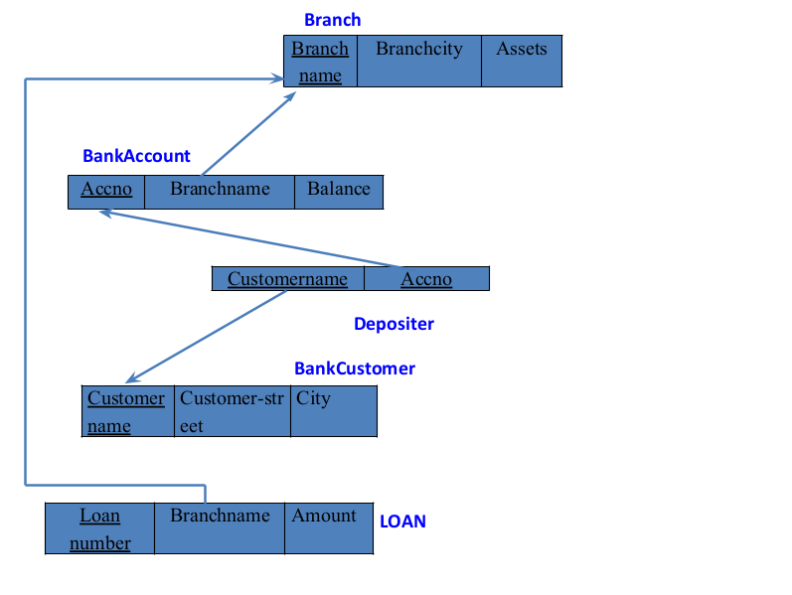

**Create database**

create database employeee11;

use employeee11;

**create table**

create table project(pno int ,pname varchar(30), ploc varchar(30),primary key(pno));

create table dept(deptnoint,dname varchar(30),dloc varchar(30),primary key(deptno));

create table employees(empno int ,ename varchar(30),mgr_no int, sal int, nom int,primary key (empno),foreign key(nom) references dept(deptno));

create table assigned_to(empno int, pno int, jobrole varchar(30),foreign key(pno) references project(pno),foreign key(empno) references employees(empno));

create table incentives(empno int references employees(empno) on delete cascade on update cascade, incentive_datedate,incentive_amtint,primary key(incentive_date), foreign key (empno) references employees(empno));

desc project;

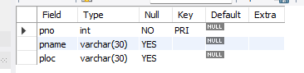

desc employees;

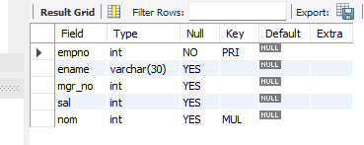

desc dept;

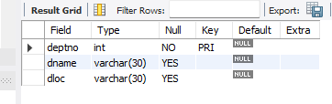

desc assigned_to;

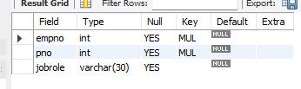

desc incentives;

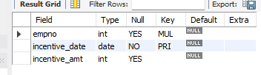

**Inserting values to the table**

insert into project values(101,'AI project','bengaluru');

insert into project values(102,'IOT','hyderabad');

insert into project values(103,'blockchain','bengaluru');

insert into project values(104,'data science','mysore');

insert into project values(105,'autonomous system','pune');

select * from project;

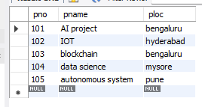

insert into dept values(10,'accounting','mumbai');

insert into dept values(20,'research','bengaluru');

insert into dept values(30,'sales','delhi');

insert into dept values(40,'operations','chennai');

select * from dept;

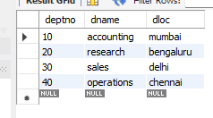

insert into employees1 values(7369,'Adarsh',7902,'2012-12-17',80000,20);

insert into employees1 values(7499,'shruthi',7698,'2013-02-20',16000,30);

insert into employees1 values(7521,'Anvitha',7698,'2015-02-22',12500,30);

insert into employees1 values(7566,'Tanvir',7839,'2008-04-02',129750,20);

insert into employees1 values(7654,'Ramesh',7698,'2014-09-28',12500,30);

insert into employees1 values(7698,'kumar',7839,'2015-05-01',28500,30);

insert into employees1 values(7782,'CLARK',7839,'2017-06-09',124500,10);

insert into employees1 values(7788,'SCOTT',7566,'2010-12-09',30000,20);

insert into employees1 values(7839,'KING',NULL,'2009-11-17',50000,10);

insert into employees1 values(7844,'TURNER',7698,'2010-09-08',15000,30);

insert into employees1 values(7876,'ADAMS',7788,'2013-01-12',11000,20);

insert into employees1 values(7900,'JAMES',7698,'2017-012-03',9500,30);

insert into employees1 values(7902,'FORD',7566,'2010-12-13',30000,20);

select * from employees1;

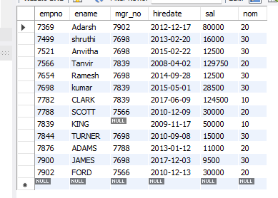

insert into assigned_to1 values(7499,101,"software engineer");

insert into assigned_to1 values(7521,101,"software architect");

insert into assigned_to1 values(7566,101,"project manager");

insert into assigned_to1 values(7654,102,"sales");

insert into assigned_to1 values(7521,102,"software engineer");

insert into assigned_to1 values(7499,102,"software enggineer");

insert into assigned_to1 values(7654,103,"cyber security");

insert into assigned_to1 values(7698,104,"software engineer");

insert into assigned_to1 values(7900,105,"software engineer");

insert into assigned_to1 values(7839,104,"general manager");

select * from assigned_to1;

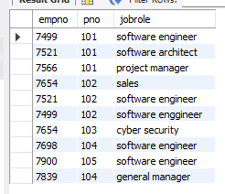

insert into incentives11 values(7499,'2019-02-01',5000);

insert into incentives11 values(7521,'2019-03-01',2500);

insert into incentives11 values(7566,'2022-02-01',5070);

insert into incentives11 values(7654,'2020-02-01',2000);

insert into incentives11 values(7654,'2022-04-01',879);

insert into incentives11 values(7521,'2019-07-01',8000);

insert into incentives11 values(7698,'2019-03-01',500);

insert into incentives11 values(7698,'2020-03-01',9000);

insert into incentives11 values(7698,'2022-04-01',4500);

select * from incentives11;

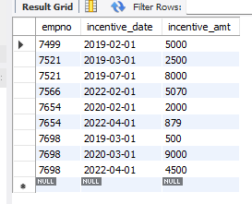

**Queries**

1.Retrieve the employee numbers of all employees who work on projectlocated in Bengaluru, Hyderabad, or Mysuru

select a.empnoemployee_number from project p,assigned_to1 a where p.pno=a.pno and p.ploc in ('hyderabad','bengaluru','mysuru');

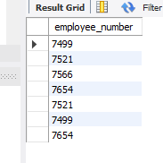

2. Get Employee ID’s of those employees who didn’t receive incentives

select e.empno from employees1 e where e.empno NOT IN (select i.empno from incentives11 );

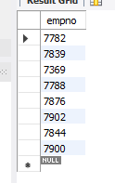

5. Write a SQL query to find the employees name, number, dept, job_role,department location and project location who are working for a projectlocation same as his/her department location.

select e.enameemp_name,e.nomemp_number,d.dname dept, a.jobrolejob_role,d.dloc where e.empno=a.empno and p.pno=a.pno and e.nom=d.deptno and p.ploc=d.dloc;

